1. I have not found anything on Keyguard for this app, just some code in SDK for google firebase.

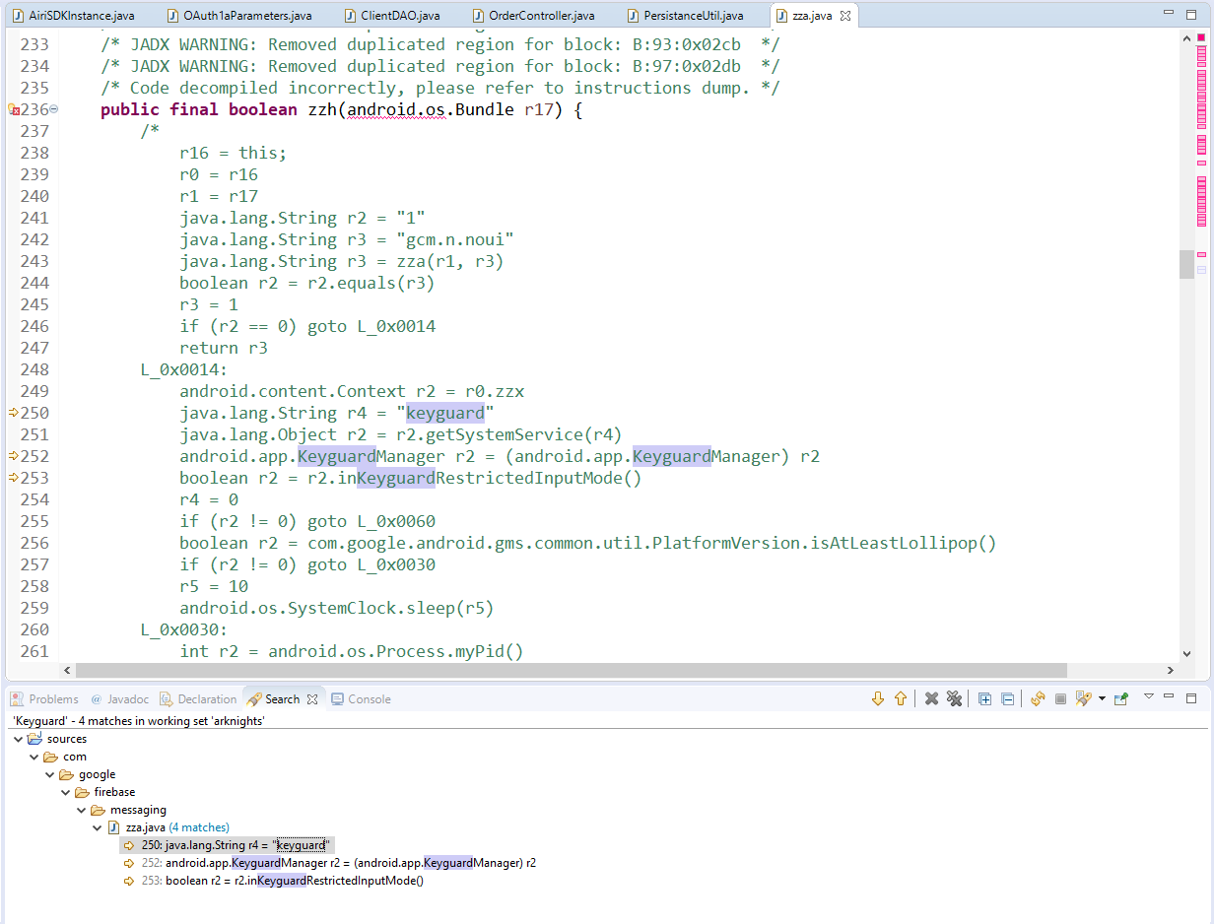

As I described some time earlier, basically app logs you out, if you go into another app, but if you stay in the app for example and lock your phone, after unlocking it, even if this app was in background for some time, you’ll be able to access it. Point to this one is so hackers won’t be able to use 3rd-party apps that provide you either some possibilities to get advantages in the app or some QoL like autoclickers and etc.

1. This app has no biometric authentication at all. All I was able to find was some code in android SDK, that is not used anywhere in the app.

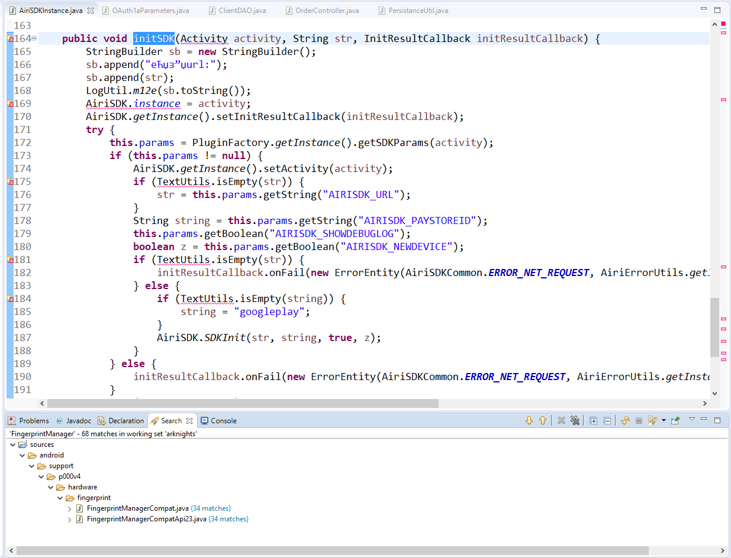

Nothing really to check there to find vulnerabilities.